**The Midwest Jr. Suffolk Show**

June 10th-12th, 2025

Missouri State Fairgrounds (Sedalia, MO)

***Entries & T-shirt sizes must be submitted by May 12th, 2025 (1 Entry Form per Exhibitor)***

**Schedule:**

* June 10th
  + 8:30 AM Lamb retreat for any juniors.
  + Noon Pizza Party.
  + 2 PM Water Park.
* June 11th
  + Check-in from 12 PM-3 PM. Check-in will take place at the sheep barn under the white tent.
  + All Photo and Art entries are to be submitted at that time as well.
  + Please have registration papers ready if copies are not provided with the entry form.
  + All animals will need health papers.
  + 2 PM-3 PM Speaking Contest for all age groups.
* June 12th Show begins promptly at 7:45 AM with a group photo.
* June 12th, Costume contest at 8:00 AM. Teams can have up to 4 members, and this is open to all breeds. No registration needed for this.
* June 12th Banquet will start at 4 PM. Please make sure you submit the number of banquet tickets your family will need.

**Divisions:**

1. Fitted
2. Slick Sheared
3. Showmanship
4. Art/Photo/ Speaking Contest

**Classes:** (Only two entries per class per exhibitor)

#1 Yearling Ram (born after 9/1/2023)

#2 Fall Ram Lamb (born 9/1/2024-12/31/2024)

#3 January Ram Lamb (born 1/1/25-1/31/25)

#4 February Ram Lamb (born 2/1/25-2/28/25)

#5 March Ram Lamb (born 3/1/25 & after)

#6 Yearling Ewe (born after 9/1/2023)

#7 Fall Ewe Lamb (born 9/1/2024-12/31/2024)

#8 January Ewe Lamb (born 1/1/2025-1/31/2025)

#9 February Ewe Lamb (born 2/1/25-2/28/25)

#10 March Ewe Lamb (born 3/1/25 & after)

#11 Senior Showmanship (Ages 16-21 by date of show)

#12 Intermediate Showmanship (Ages 12-15 by date of show)

#13 Junior Showmanship (Ages 8-11 by date of show)

#14 Novice Showmanship (7 and under)

#15 Senior Photo (Ages 16-21 by date of show)

#16 Intermediate Photo (Ages 12-15 by date of show)

#17 Junior Photo (Ages 8-11 by date of show)

#18 Novice Photo (7 and under)

#19 Senior Art (Ages 16-21 by date of show)

#20 Intermediate Art (Ages 12-15 by date of show)

#21 Junior Art (Ages 8-11 by date of show)

#22 Novice Art (7 and under)

#23 Senior Speaking Contest(Ages 16-21 by date of show)

#24 Intermediate Speaking Contest (Ages 12-15 by date of show)

#25 Junior Speaking Contest (Ages 8-11 by date of show)

#26 Novice Speaking Contest (7 and under)

Entry Form

***Entries & T-shirt sizes must be submitted by May 12th, 2025 (1 Entry Form per Exhibitor)***

Exhibitor Name:__________________ Date of Birth:_____ T-Shirt Size: __

Address:________________________ City:________________________

State:__________________________ Zip Code:____________________

Phone:_________________________ Email:_______________________

Water Park: Pizza Party:______ Lamb retreat: _______________

* Entries are $10 per head.
* No Entry Fee for Showmanship, Fitting, Photo, Art or Speaking Contest.
* Entries must be paid at the time of Entry.
* Extra T-shirts can be ordered for $12 each please include the size and the number of shirts.
* If you will be attending the Waterpark, Pizza Party, or Lamb retreat please provide number of family members.

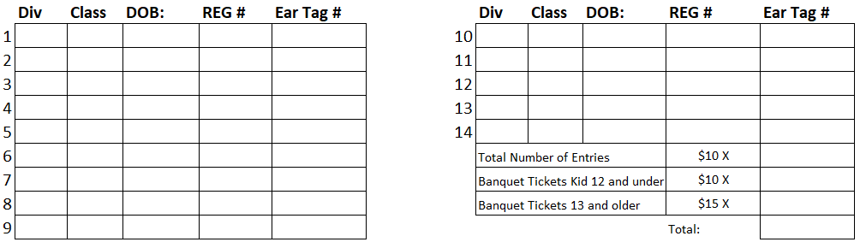

***All Registration papers are to be reviewed at check-in.***

***Make checks payable to: The Midwest Jr. Suffolk Show***

***Mail entries to:***

***Cynthia Huckins***

***HC 36 Box 33***

***Spring Creek, NV 89815***

***Questions, email: (Lorie Oelke)*** [***lorie.oelke@icloud.com***](mailto:lorie.oelke@icloud.com) ***or 218-713-7032***

***Questions, email: (Cynthia Huckins)***[***rubymtsheepco@yahoo.com***](mailto:rubymtsheepco@yahoo.com) ***or 775-741-0789***

***Questions, email: (Matt Wolf)***[***mgwolf78@gmail.com***](mailto:mgwolf78@gmail.com) ***or 208-695-8495***